**David Wolfe List and Carolyn**

**Huffer List Family**

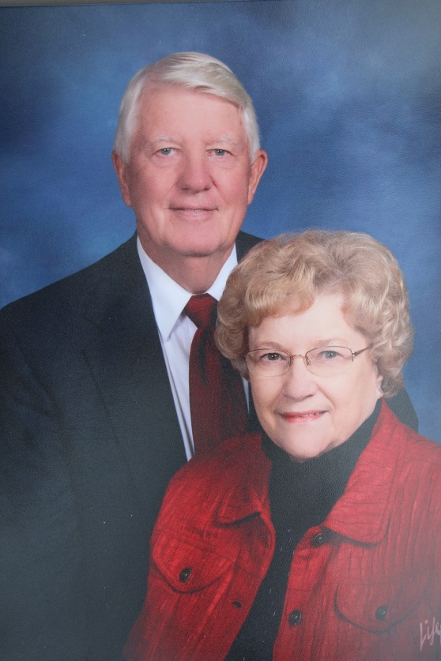

David Wolfe & Carolyn Huffer List – 2012

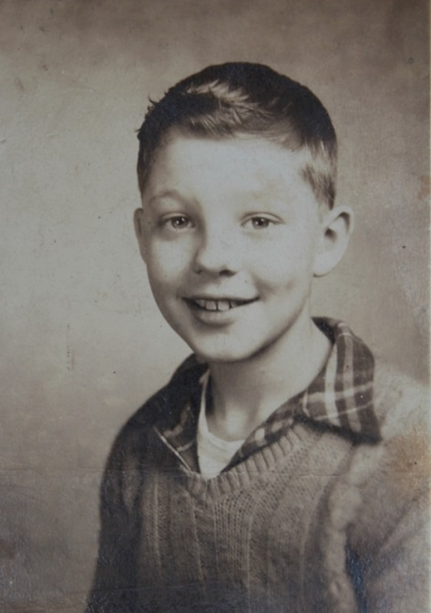

**David Wolfe List – 1945**